PAGE ONE
Panel #1: Side shot of a Grey 2000 Honda CRV rear passenger seat being shut. A hand is left in the frame as the door closes. In the distance, a few hospital buildings can be seen.

Panel #2: Ariel shot of the Grey Honda. Trail marks of Mom are seen as she runs back and forth closing and opening other doors making sure she has secured Sensitive in his seat, has her diaper bag correctly placed, and has her clothes and jacket in the passenger seat.

Panel #3: Interior shot looking from the driver’s passenger seat. Mom with one hand has turned on the car and is waving bye to a good number of hospital workers lined up watching. Some are waving back and surprised at her moves as she moves quickly, and most are standing there watching with hands out almost as if she needs help. The hospital staff seem a bit overdressed, with each wearing gloves and hospital masks that block their face in the middle of the day (not too noticeable though).
Mom: Bye!!
Panel #4: A close-up shot of Mom sitting in the car after she turned the ignition. The car engine vrooms and she begins to slightly. Beautiful thick curls, a youthful vibrant light skin tone. The door is closed and she looks straight ahead. Noise from the hospital workers still loudly saying bye pierced the side panel. A portion of the car seat can be seen seated on the right of Mom.

Panel #5: Mom turns around to see Sensitive giggling and gurgling. Mom looks tiredly at Sensitive yet with a bright smile says ~
Mom: Home.
PAGE TWO
Panel #6: A frontal shot of the Honda CRV as it begins turning into a long freshly painted road extensively surrounded by forest trees.
Panel #7: The midday scene extends into a wide and
far off shot overlooking sideways shot looking at the island that Sensitive and his family are located on. From this angle the disparity of trees can be clearly shown, with the left side of the city looking more barren than the right side (which is the side that Mom is driving into). The town looks as if it had recently been given an all clear for the woodcutters to flatten as much as they could and were making their way to finish the job.

Panel #8: a far off Ariel shot of the same island. The deforestation is widely more visible on the south side of the island. Modern buildings not more than 3 stories tall are scattered throughout the southern side of the island with a littering of trees lining up and around them, and seemingly converging (not too obviously) at a focal northern point.

Panel #9:

PAGE ONE INSPO SHOTS + MISC
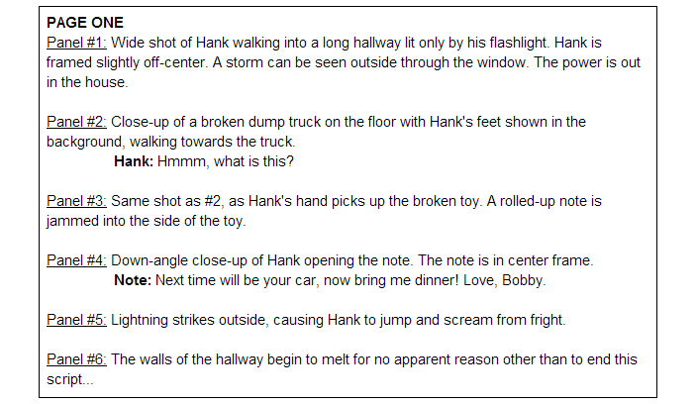

The car that I want to use:
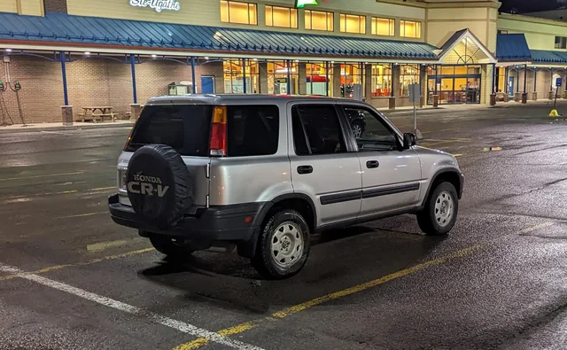
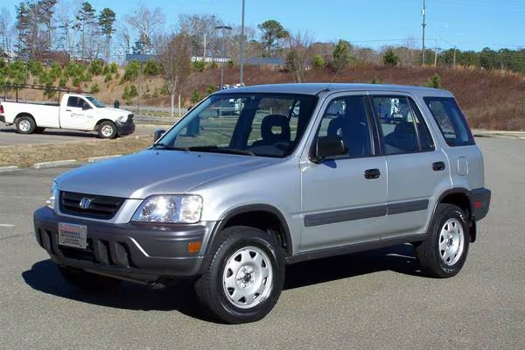
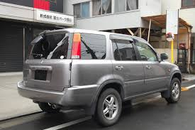

Panel 1:
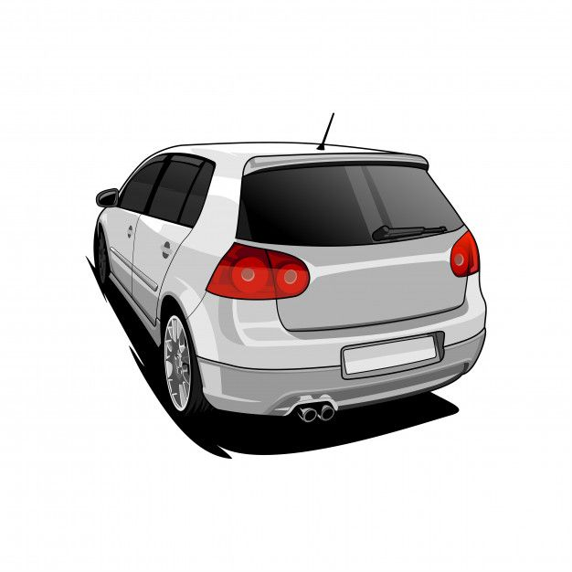

Panel 2:
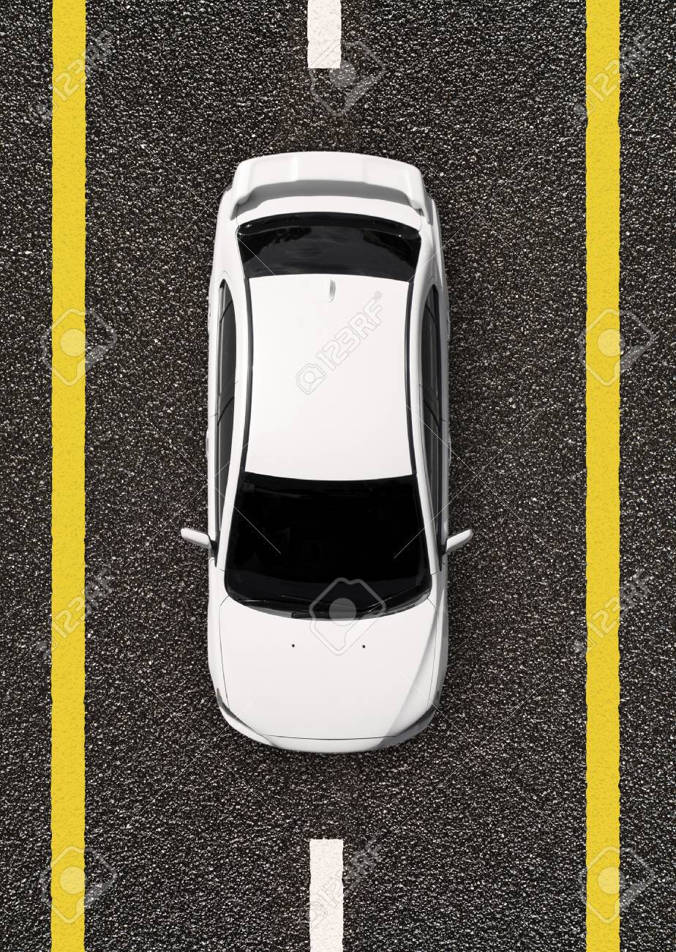

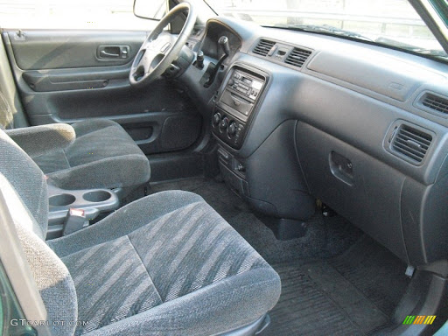
Panel 3:
